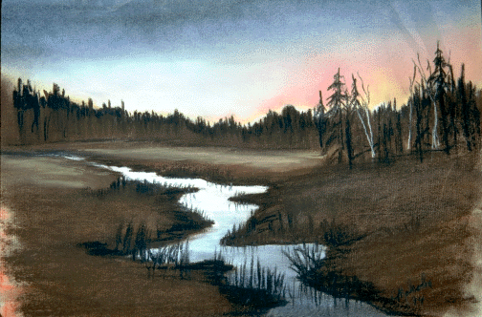

Friend, today your search can be over.

Deliverance Center
1008 Congress Street
Portland, Maine
(207) 774-8192

Sunday School..........................................10:00 a.m.
Sunday Morning Service..........................11:00 a.m.
Sunday Evening Service……………...…6:30 p.m.
Wednesday Bible Study…………………7:00 p.m.
Friday Night Youth Service…………..…7:00 pm.

VISIT US ANYTIME!!!
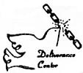

Have You Found

Outside Tract
A

What Your Searching For ?

Outside Tract
B

